Docker Assignment 1

Sap: 500110800

This project has been made on linux. All the screencshots for commands used throughout are given bellow.

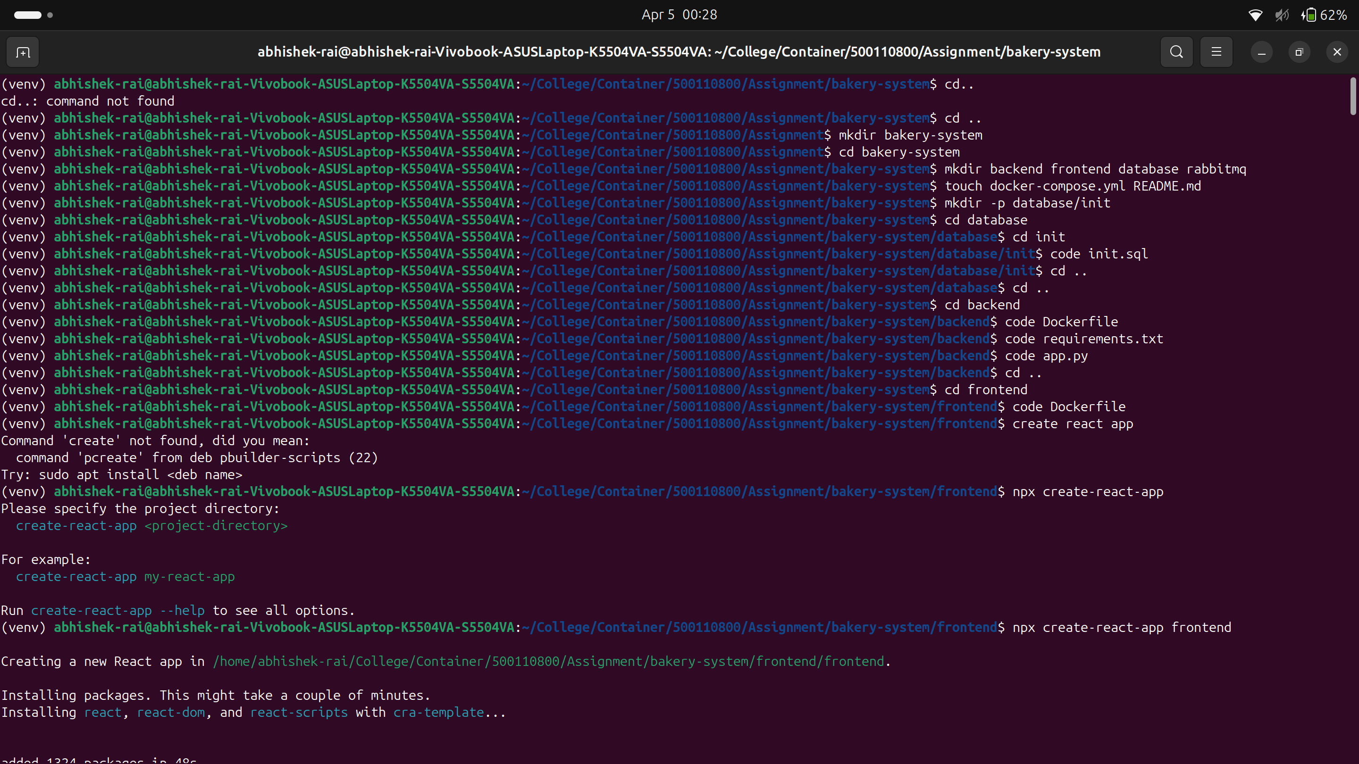
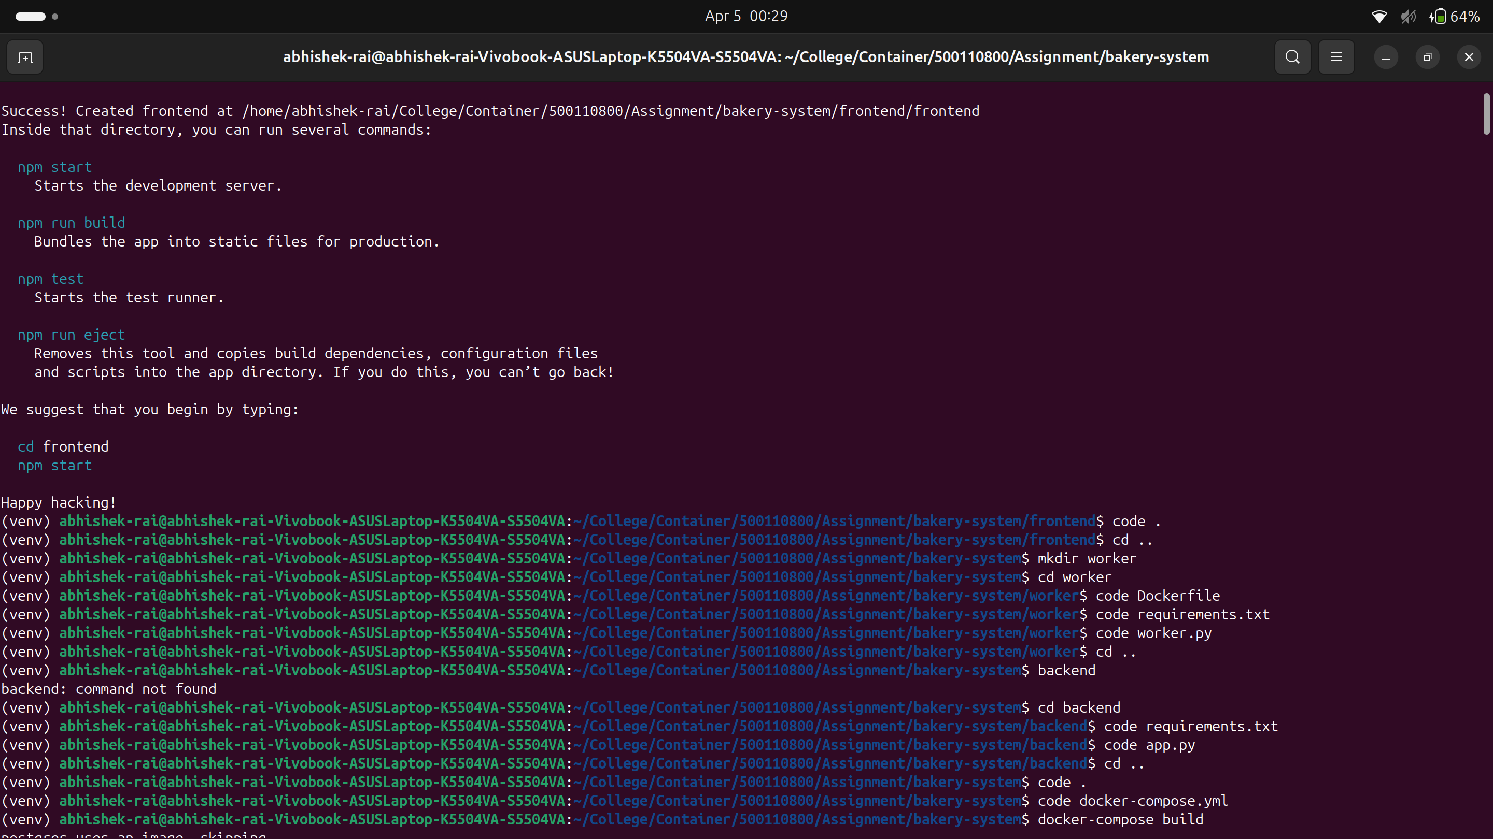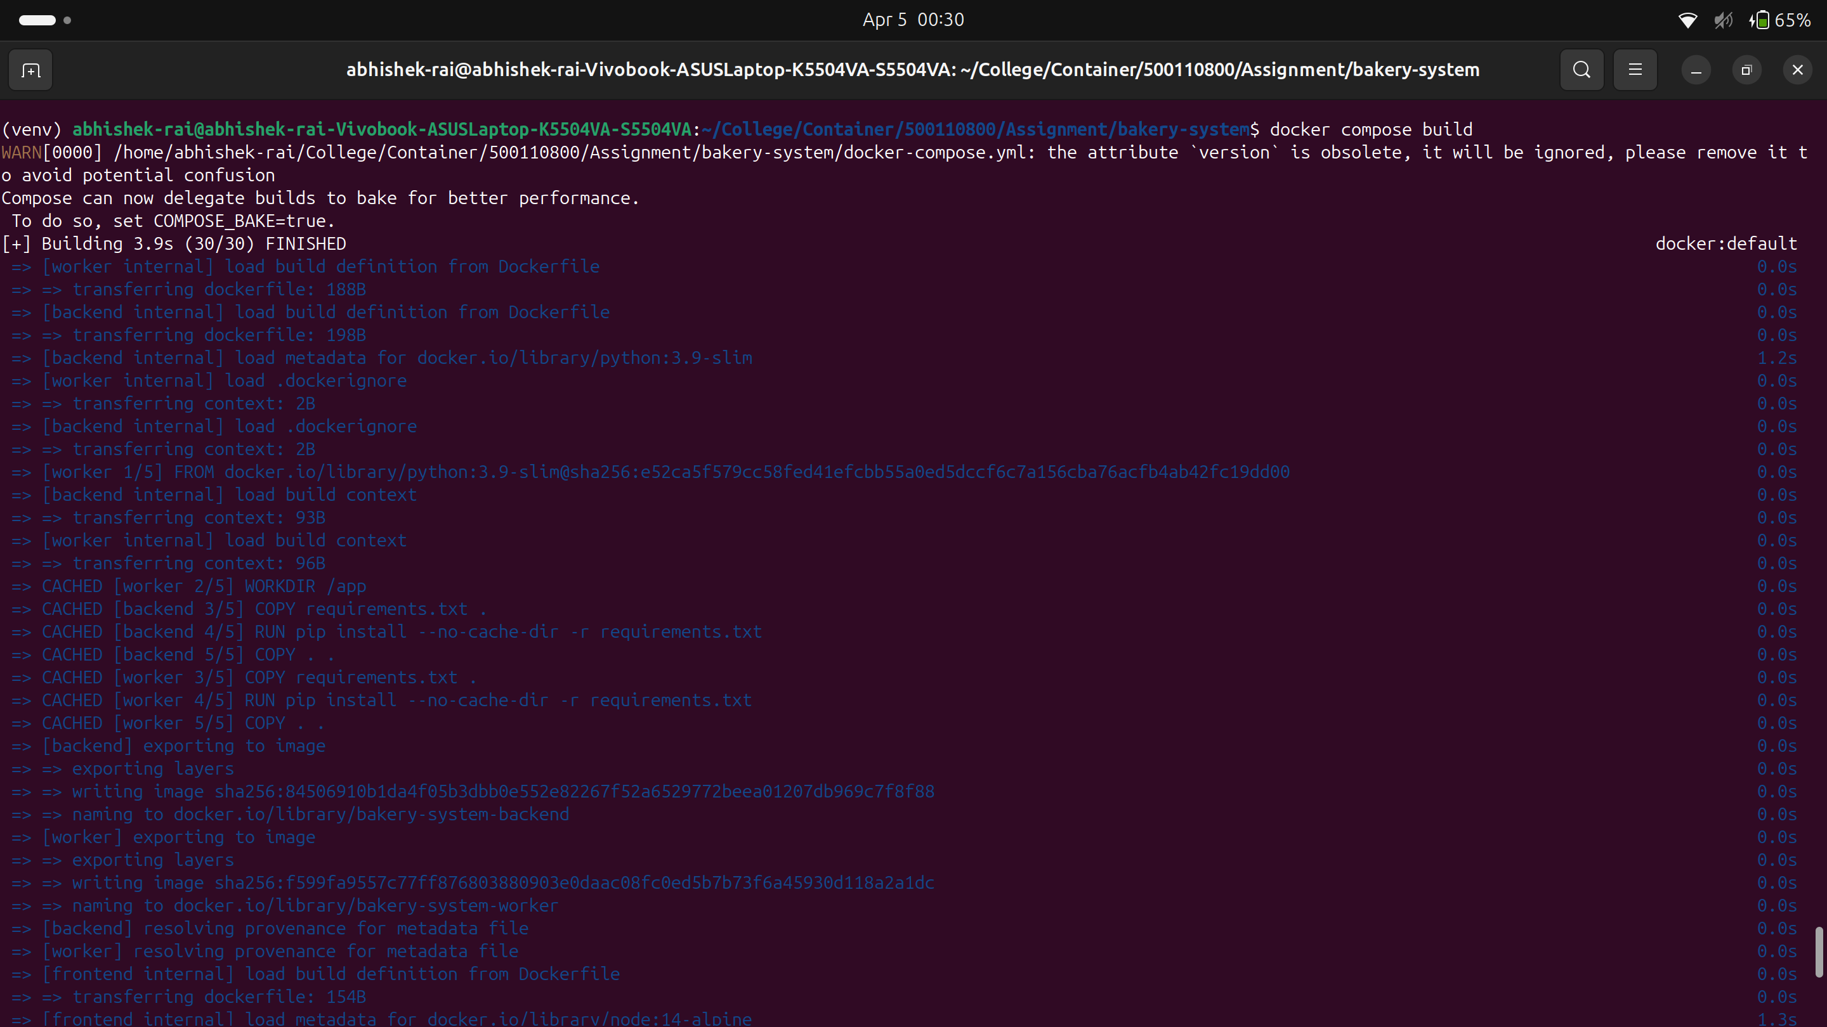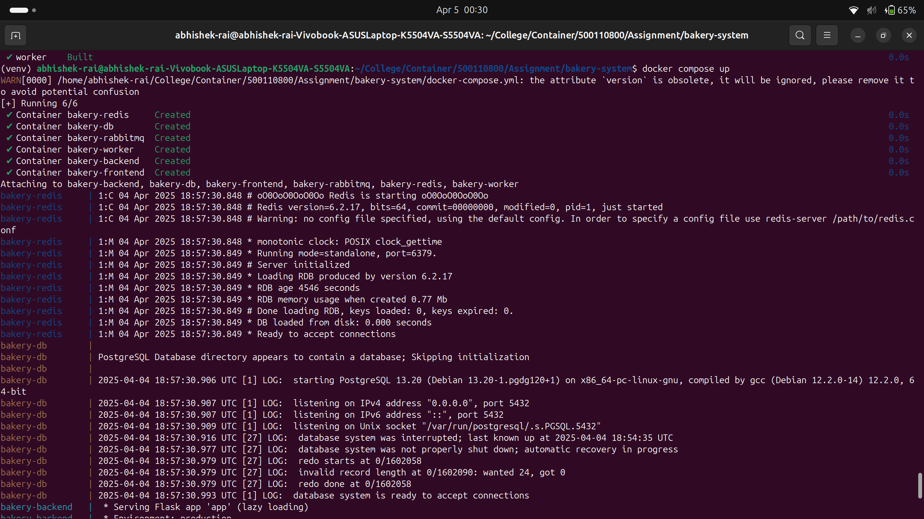

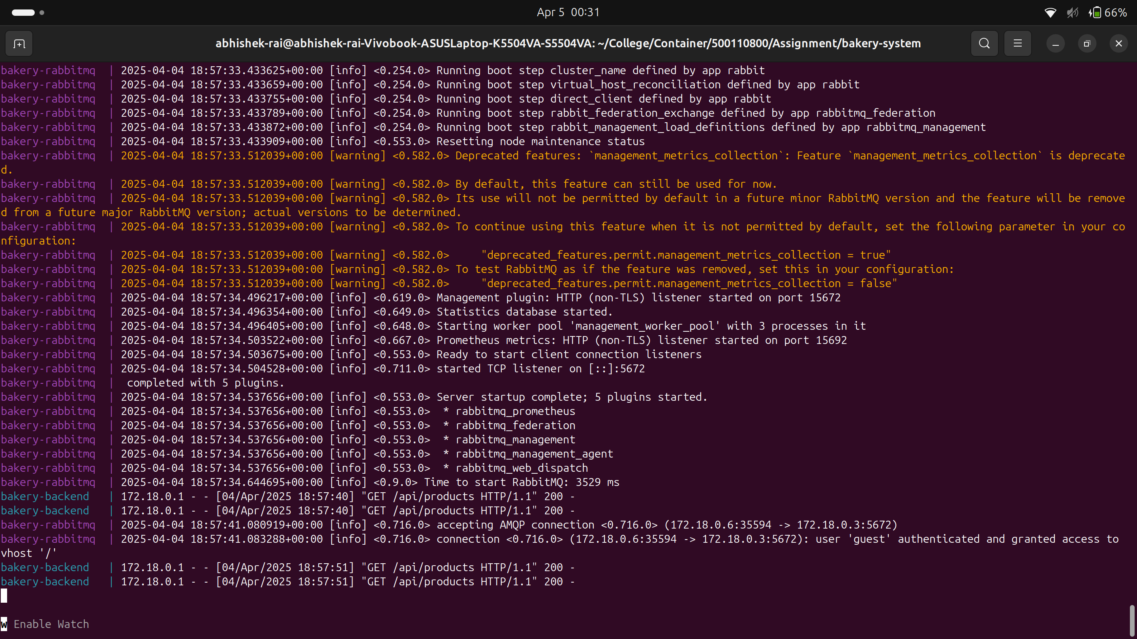

Database Container
CREATE TABLE products (
id SERIAL PRIMARY KEY,
name VARCHAR(100) NOT NULL,
description TEXT,
price DECIMAL(10, 2) NOT NULL,
image_url VARCHAR(255),
created_at TIMESTAMP DEFAULT CURRENT_TIMESTAMP
);

CREATE TABLE orders (
id SERIAL PRIMARY KEY,
customer_name VARCHAR(100) NOT NULL,
customer_email VARCHAR(100) NOT NULL,
status VARCHAR(50) DEFAULT 'pending',
created_at TIMESTAMP DEFAULT CURRENT_TIMESTAMP
);

CREATE TABLE order_items (
id SERIAL PRIMARY KEY,
order_id INTEGER REFERENCES orders(id),
product_id INTEGER REFERENCES products(id),
quantity INTEGER NOT NULL,
unit_price DECIMAL(10, 2) NOT NULL
);

-- Insert some sample products
INSERT INTO products (name, description, price, image_url) VALUES
('Chocolate Cake', 'Rich chocolate layer cake with ganache', 29.99, 'https://www.bbc.co.uk/food/recipes/easy_chocolate_cake_31070'),
('Sourdough Bread', 'Artisanal sourdough bread', 8.99, 'https://cookidoo.co.uk/recipes/recipe/en-GB/r643607'),
('Blueberry Muffin', 'Moist muffin loaded with blueberries', 3.99, 'https://www.wildernesswife.com/blog/2019/08/04/jordan-marsh-blueberry-muffin-recipe/'),
('Croissant', 'Buttery, flaky French pastry', 4.50, 'https://www.istockphoto.com/photos/butter-croissant');

volumes:
postgres_data:
redis_data:
rabbitmq_data:

Database in compose file
postgres:
image: postgres:13
container_name: bakery-db
environment:
POSTGRES_USER: postgres
POSTGRES_PASSWORD: postgres
POSTGRES_DB: bakery
volumes:
- postgres_data:/var/lib/postgresql/data
- ./database/init:/docker-entrypoint-initdb.d
ports:
- "5432:5432"
healthcheck:
test: ["CMD-SHELL", "pg_isready -U postgres"]
interval: 10s
timeout: 5s
retries: 5
restart: unless-stopped

Docker Compose file used
version: '3.8'

services:
postgres:
image: postgres:13
container_name: bakery-db
environment:
POSTGRES_USER: postgres
POSTGRES_PASSWORD: postgres
POSTGRES_DB: bakery
volumes:
- postgres_data:/var/lib/postgresql/data
- ./database/init:/docker-entrypoint-initdb.d
ports:
- "5432:5432"
healthcheck:
test: ["CMD-SHELL", "pg_isready -U postgres"]
interval: 10s
timeout: 5s
retries: 5
restart: unless-stopped

redis:
image: redis:6
container_name: bakery-redis
ports:
- "6379:6379"
volumes:
- redis_data:/data
healthcheck:
test: ["CMD", "redis-cli", "ping"]
interval: 10s
timeout: 5s
retries: 5
restart: unless-stopped

rabbitmq:
image: rabbitmq:3-management
container_name: bakery-rabbitmq
ports:
- "5672:5672"
- "15672:15672"
volumes:
- rabbitmq_data:/var/lib/rabbitmq
healthcheck:
test: ["CMD", "rabbitmqctl", "status"]
interval: 30s
timeout: 10s
retries: 5
restart: unless-stopped

backend:
build: ./backend
container_name: bakery-backend
depends_on:
- postgres
- rabbitmq
- redis
environment:
DB_HOST: postgres
DB_NAME: bakery
DB_USER: postgres
DB_PASSWORD: postgres
RABBITMQ_HOST: rabbitmq
REDIS_HOST: redis
ports:
- "5000:5000"
restart: unless-stopped
healthcheck:
test: ["CMD", "curl", "-f", "http://localhost:5000/health"]
interval: 30s
timeout: 10s
retries: 3

worker:
build: ./worker
container_name: bakery-worker
depends_on:
- postgres
- rabbitmq
environment:
DB_HOST: postgres
DB_NAME: bakery
DB_USER: postgres
DB_PASSWORD: postgres
RABBITMQ_HOST: rabbitmq
restart: unless-stopped

frontend:
build: ./frontend
container_name: bakery-frontend
depends_on:
- backend
environment:
REACT_APP_API_URL: http://localhost:5000
ports:
- "3000:3000"
restart: unless-stopped

volumes:
postgres_data:
redis_data:
rabbitmq_data:

Dockerfile for Frontend
FROM node:14-alpine

WORKDIR /app

COPY package*.json ./
RUN npm install

COPY . .

EXPOSE 3000

CMD ["npm", "start"]
Dockerfile for Backend
FROM python:3.9-slim

WORKDIR /app

COPY requirements.txt .
RUN pip install --no-cache-dir -r requirements.txt

COPY . .

EXPOSE 5000

CMD ["python", "app.py"]
requirements.txt for backend
FROM python:3.9-slim

WORKDIR /app

COPY requirements.txt .
RUN pip install --no-cache-dir -r requirements.txt

COPY . .

EXPOSE 5000

CMD ["python", "app.py"]

Flask==2.0.1
Werkzeug==2.0.3
Flask-CORS==3.0.10
psycopg2-binary==2.9.1
pika==1.2.0
redis==3.5.3
Dockerfile for Worker.py
FROM python:3.9-slim

WORKDIR /app

COPY requirements.txt .
RUN pip install --no-cache-dir -r requirements.txt

COPY . .

CMD ["python", "worker.py"]
requirements.txt for worker
psycopg2-binary==2.9.1
pika==1.2.0
RabbitMq
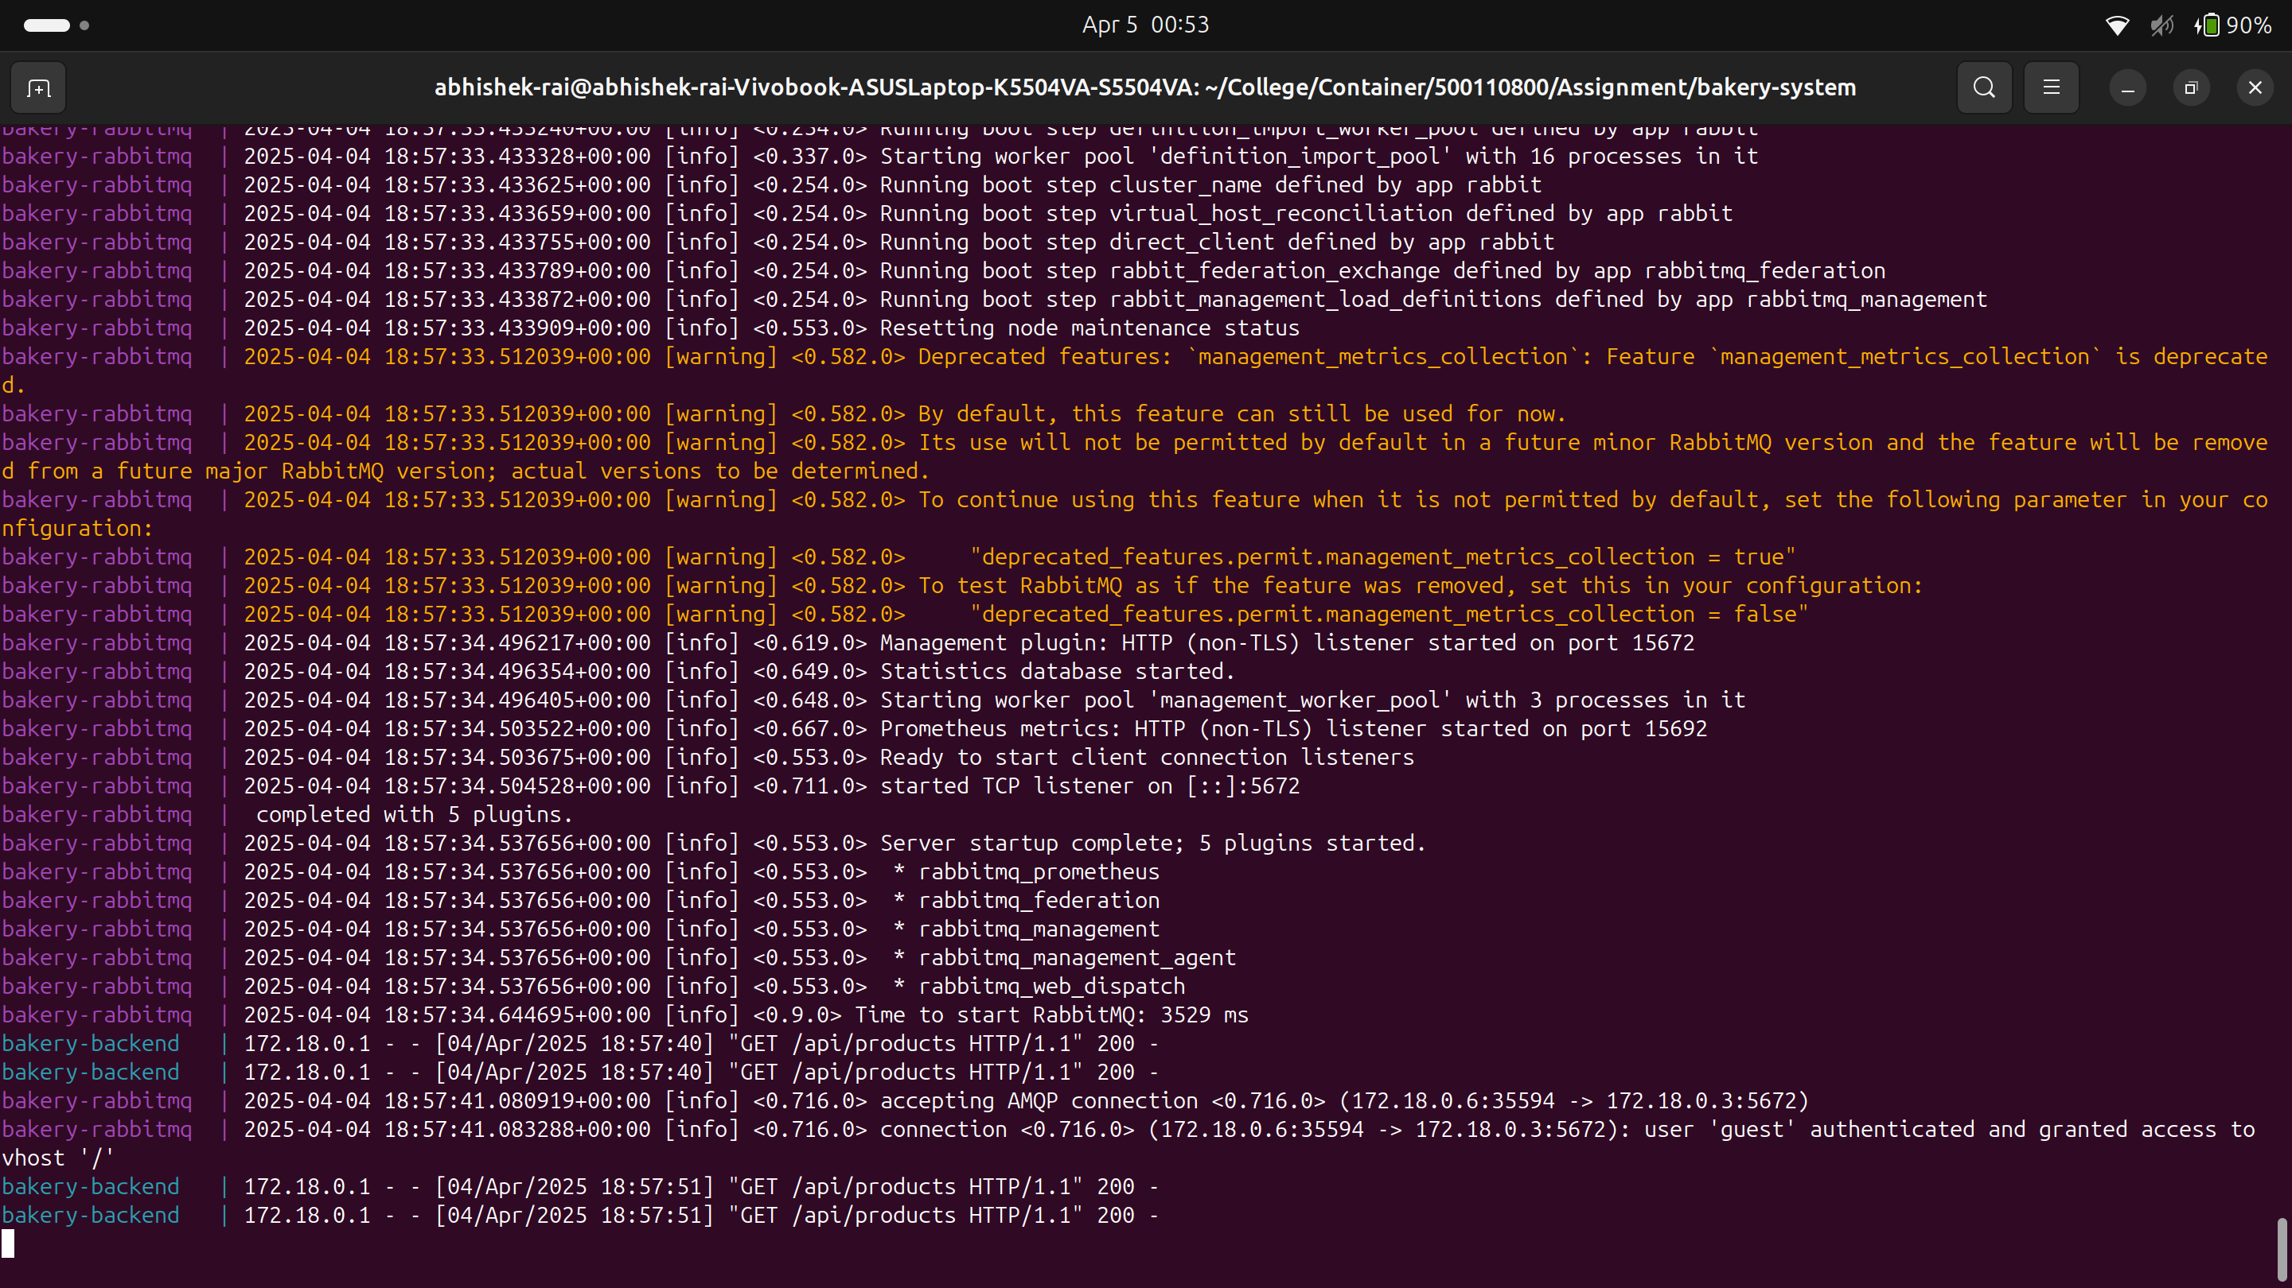

Additional Notes for Advanced Features

1. Redis Caching
The Redis caching implementation provides:
- Reduced database load by caching product listings
- Faster response times for frequently accessed data
- Cache invalidation when orders are placed to ensure data consistency

It has been implemented in the backend code and is imported through compose.yml

redis:
image: redis:6
container_name: bakery-redis
ports:
- "6379:6379"
volumes:
- redis_data:/data
healthcheck:
test: ["CMD", "redis-cli", "ping"]
interval: 10s
timeout: 5s
retries: 5
restart: unless-stopped

2. Worker Service with RabbitMQ
The worker service:
- Processes orders asynchronously to improve scalability
- Updates order status in the database as processing progresses
- Implements retry logic and error handling for robustness
rabbitmq:
image: rabbitmq:3-management
container_name: bakery-rabbitmq
ports:
- "5672:5672"
- "15672:15672"
volumes:
- rabbitmq_data:/var/lib/rabbitmq
healthcheck:
test: ["CMD", "rabbitmqctl", "status"]
interval: 30s
timeout: 10s
retries: 5
restart: unless-stopped

Results


